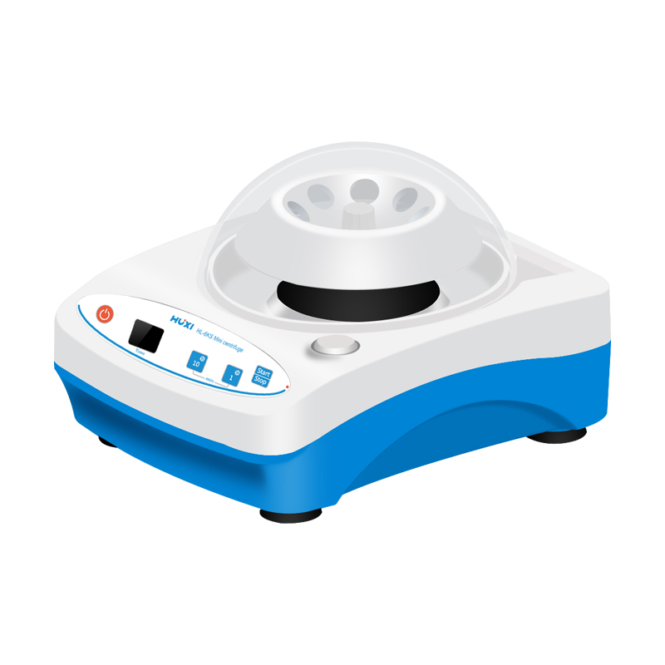

# **HL-11KS Micro Centrifuge**

# **Shaker**

# HT-S330 **Rotary Shaker**

**Application：**

The HL-11KS miniature handheld centrifuge has a novel and unique appearance, is agile and versatile, equipped with various centrifuge rotors and test tube sleeves, suitable for 2.0ml, 1.5m centrifuge tubes and 8x4x0.2ml PCR tubes, and is widely used in industries such as chemical, pharmaceutical, and food.

**Main Features：**

* Convenient and efficient multiple rotors, compatible with a variety of 2.0ml and 1.5ml centrifuge tubes;
* Adopting high-frequency wide-voltage power supply technology, with an input voltage range of 100~240V to ensure operation;
* Unique rotor snap design, convenient for rotor replacement;
* Lower noise, stable operation, durable, safe and reliable DC motor;
* Human design, semi-automatic opening function, automatic stopping time within 3 seconds of opening time;
* Transparent spherical cover, equipped with multiple rotors, achieving the best effect in the pursuit of creativity and simplicity, injecting human colors into the scientific and rational laboratory products.

**Technical Parameters：**

|  |  |
| --- | --- |
| Model | HL-11KS |
| Speed Fixed | 11000 rpm |
| RCF | |  |  | | --- | --- | | 7100 xg | | |  | | |
| Open Cover | Semi automatically |
| Cover opening system protection | Double brake insurance |
| Speed add time | 90% of rated speed within 5 seconds |
| Speed minus time | within 3s after the lid is opened |
| Rotor | 8*2ml/1.5ml angle rotor 8*4*0.2ml PCR tube |
| Operation Time | Continuous/Timing1~99min |
| Motor | |  |  | | --- | --- | | DC motor | | |  | | |
| Input Power | AC100~240V /50/60HZ |
| Exterior Dimension | 175*135*120mm |
| Net Weight | 1.6kg |